**Supplementary Material for HYDRAFloods Module 2**

Common Errors in HYDRAFloods and Their Solutions

SERVIR Science Coordination Office

Curriculum Development Team

Micky Maganini

Contact: [mrm0065@uah.edu](mailto:mrm0065@uah.edu)

Prepared for “Observing and Modelling Surface Water in a Changing World” at ITC

Quartile 3 2022-2023

This document contains some common errors that you may encounter when working with HYDRAFloods, and will show you how to solve them.

# **Error 1: Dictionary Does not Contain bucketMeans**

This error will occur when performing thresholding in order to map surface water

**Solution**: You need to give the edge otsu algorithm a “thresh_no_data” parameter

# **Error 2: Entire Scene not showing up when getting an hf.Dataset**

This does not return an error in HYDRAFloods, but your entire region of interest may not be covered by the image displayed. This occurs when a region of interest is on the edge of a certain image scene. 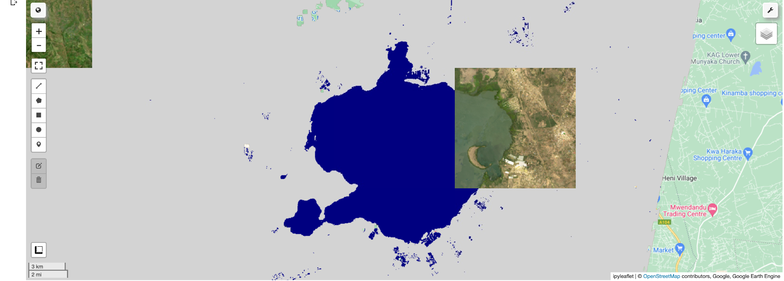

**Solution:** Make region of interest smaller and move slightly until entire ROI is displayed

# **Error 3: Too many concurrent aggregations (Google API Client Sleeping)**

This error is caused due to Earth Engine limitations of your computing power. Essentially, you are asking GEE to do too much. Google Earth Engine changes its allocation of resources based on the current number of users. This causes this error to be returned sometimes even when the same code may have previously been working.

**Solution:**

1. Wait for a bit, then try again
2. Comment out some lines of your code using “#” at the beginning of the line, then try again

# **Error 4: Computation Timed Out**

This error occurs when you try to run a computationally intensive code cell using a slow or intermediate internet connection. In order to use HYDRAFloods effectively, a good internet connection is needed to use HYDRAFloods.

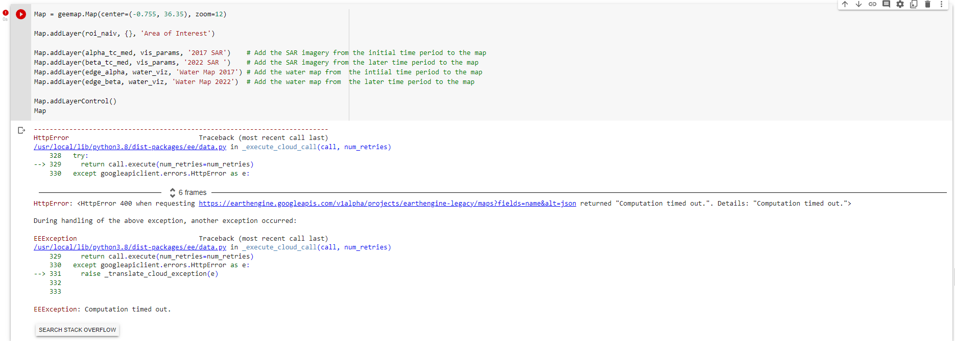

**Solution:**

1. Comment some lines of the code out and run the cell again
2. Split the code into different cells
3. If problem persists after solutions 1 and 2, you may have to navigate to a place with a more stable

# **Error 5: Map Interface Not Displaying**

This error is not from HYDRAFloods, but is a bug in the geemap package (see code below) that occurs when you try to visualize your map in the Python interface. In this case, the code runs, but the Map does not display

Map.addLayer(________)   
Map

**Solution:**

1. To the left of the Map Interface, hover over the exit button (indicated by the picture below). The button will now become an “X”. Click this button to close the map window and rerun the cell
2. If problem persists, go to Runtime → Restart runtime at the top taskbar of your notebook. You will have to run all of the cells in the notebook again



# **Error 6: Unable to Load Colaboratory**

This error occurs when you attempt to open a Google Colab Notebook. It results from having too many colaboratory tabs open at once.

**Solution:**

1. Close some of your Google Colab Notebooks and attempt to open the notebook again

